Mauritania

## Political Stability Estimate Data

The data set shows the political stability estimate of the country each year.

## # A tibble: 19 x 5  
## country iso3c date stability stabilityCategory4   
## <chr> <chr> <dbl> <dbl> <chr>   
## 1 Mauritania MRT 1996 0.368 moderately stable   
## 2 Mauritania MRT 1998 0.352 moderately stable   
## 3 Mauritania MRT 2000 0.344 moderately stable   
## 4 Mauritania MRT 2002 0.381 moderately stable   
## 5 Mauritania MRT 2003 0.0598 moderately stable   
## 6 Mauritania MRT 2004 -0.165 moderately unstable  
## 7 Mauritania MRT 2005 -0.230 moderately unstable  
## 8 Mauritania MRT 2006 0.239 moderately stable   
## 9 Mauritania MRT 2007 -0.278 moderately unstable  
## 10 Mauritania MRT 2008 -0.642 moderately unstable  
## 11 Mauritania MRT 2009 -0.884 moderately unstable  
## 12 Mauritania MRT 2010 -1.08 highly unstable   
## 13 Mauritania MRT 2011 -1.17 highly unstable   
## 14 Mauritania MRT 2012 -1.13 highly unstable   
## 15 Mauritania MRT 2013 -1.01 highly unstable   
## 16 Mauritania MRT 2014 -0.590 moderately unstable  
## 17 Mauritania MRT 2015 -0.638 moderately unstable  
## 18 Mauritania MRT 2016 -0.747 moderately unstable  
## 19 Mauritania MRT 2017 -0.619 moderately unstable

## Political Stability Estimate Plot

The plot shows the trends of stabilization and destabilization for the each country.

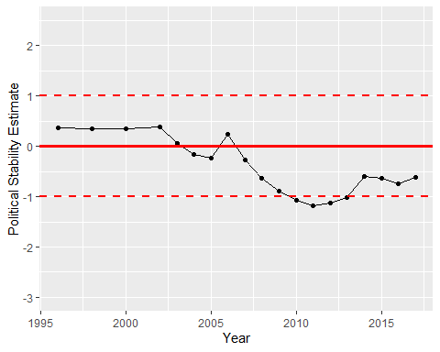

Political Stability Trend